**CO-1**

**Home Assignment**

1. Make a memory utilization check script on Linux host, and if it’s lower than 1GB throw an error "Minimum of 1GB RAM is required."  
   Verify exit code with help of: echo $

ANS:

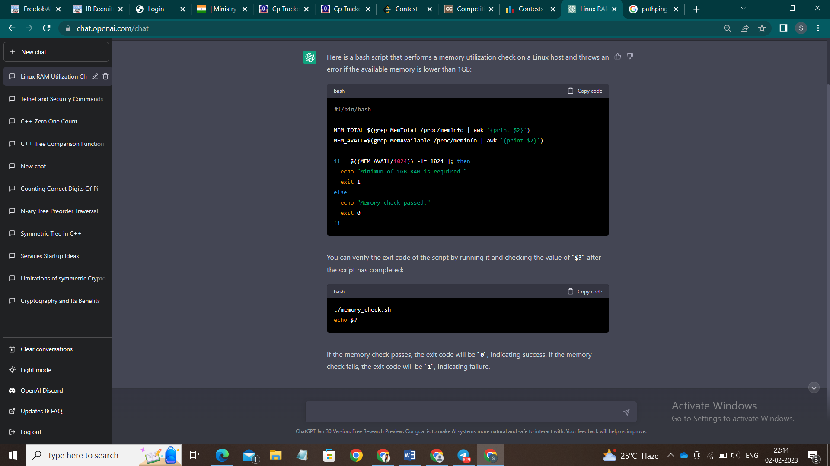

1. **Create a backup script:**  
   it should have configurable parameters: backup directory, list of directories to backup, database name and user.  
   Files should be archived using tar command and compressed. Then placed in backup directory with date tag.  
   Database should be dumped and then archived using tar command and compressed.  
   Then placed in backup directory with date tag.  
   Add this script to crontab.  
   Modify script so it will make separate daily and weekly backups.  
   Add rotation script so it will keep only last 7 daily backups and 4 last  
   weekly backups.

ANS:

